**Overview**

GlobalMart - Scalability issue, robust backend - code reuse

* regions - North America, Germany, USA, SA

- each region has 100s of shops

- each shop has 100s of items

- Z axis scaling for performance, DB partition can be done based on region

* Service oriented app

functionalities - inventory management, customer-browse, shop, find store location

- y axis scaling by implementing micro services for each functionality

- transactional - spring tx management will be used

* vendor lock in issue

Need to go through each provider policy in detail, and support for data movement and migration. Chose a provider, who has pledged to support emerging industry standards

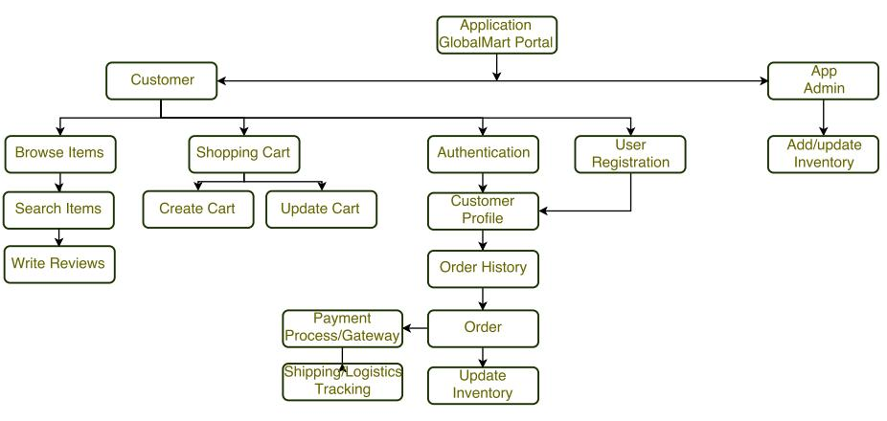**Functional decomposition**

**Use Case Model**

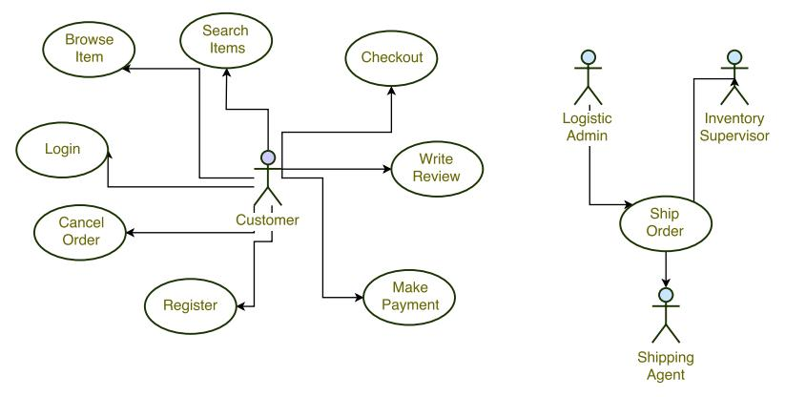

**Layered Architecture**

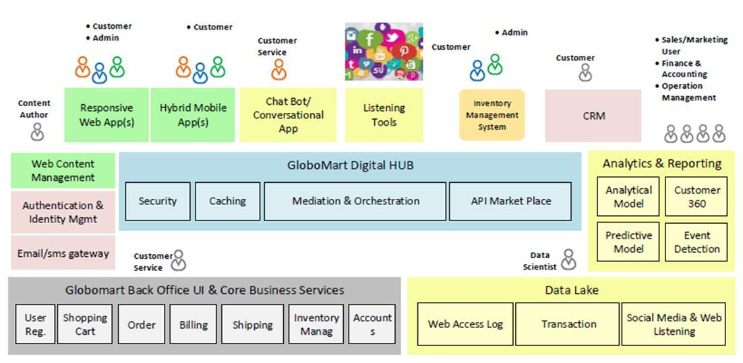

**Object Model**

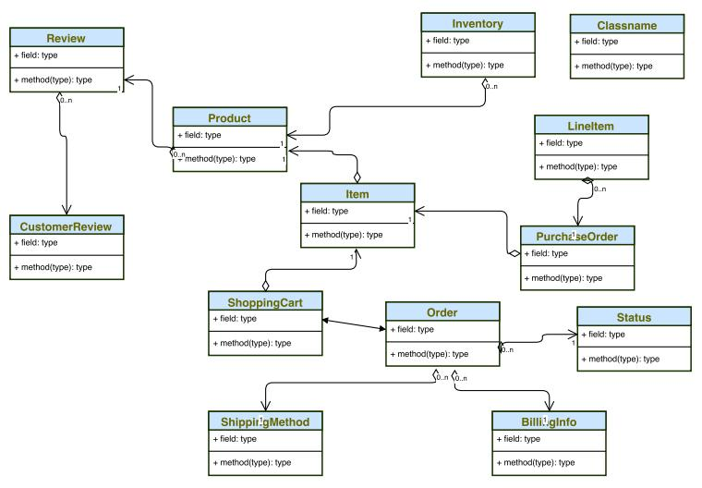

**Assumptions**

* Single application instance to serve multiple geo location
* Geo location specific inventory management or database
* Geo location specific logistics integration
* It is not to be a market place for third party sellers. It is only for GloboMart specific inventory
* Geo specific product inventory to store prices in local currency. Payment gateway to handle if payment made in other currency
* AWS Cloud would be preferred choice for implementation and to handle vertical auto scaling
* ASP to be determined for a time period based on no. of unit sold and revenue

**Content Management**

* Channels (Web, Digital etc.) to be decoupled from the backend platform. All communication to happen via common set of micro-services using restful calls. This will ensure same content versions for all channels
* Updates to catalog/products information should follow standard CMS workflow like Creator → Editor → Publisher etc.

**Business Risks**

* Possibilities of refund and reorder
* Logistic cost overhead on refunds
* Security risk like customer data (PII), price overriding via web proxies may impact the credibility of the business

**Deployment Model**

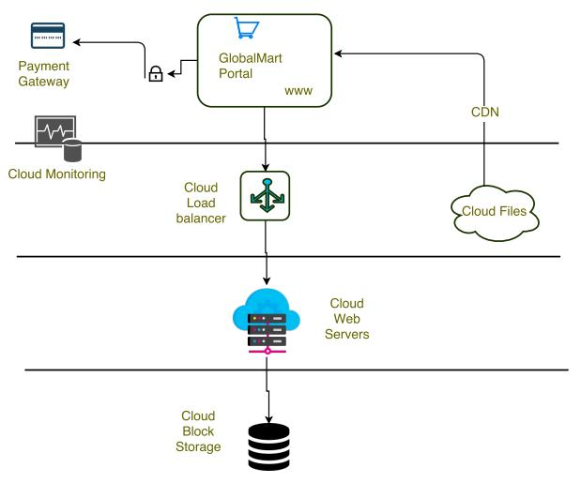

**Solution to be provided...**

Product Catalogue Service

Microservice that provides the functionality to

* Add a product
* Retrieve the list of products based on simple search criteria e.g. product type
* Remove a product from the catalogue.